TABLE OF CONTENTS

CHAPTER 4: SYSTEM DESIGN 2

1.0 INTRODUCTION 2

1.1 FUNCTIONAL MODELING 2

1.1.1 Context diagram 2

Context Diagram 2

1.1.2 Data flow diagram 3

Level 1 Data Flow Diagram 3

1.2 SYSTEM MODELING 4

1.2.1 System flow chart 4

1.3 DATA MODELING 5

1.3.1 Entity Relationship Diagram (ERD) 5

1.3.2 Use Cases 7

1.4 DATABASE & FILE DESIGN 8

1.5 INTERFACE DESIGN 8

1.5.1 System Interface design 8

1.5.2 Human-Computer Interface design (HIC) 8

1.6 SECURITY DESIGN 13

1.7 CONCLUSION 14

# CHAPTER 4: SYSTEM DESIGN

## INTRODUCTION

Now that the analyst has all the requirements for the proposed system, it is the time to use all those requirements to make design choices. According to *Kassem A. Saleh (2009)*, the design phase is initiated after the deliverables of the analysis phase are reviewed and accepted by the appropriate stakeholders and this phase includes the activities such as high-level architectural, database, interface, and detailed designs. The main deliverables of this phase include the high-level design and detailed design documents which will be reviewed for quality, completeness, and correctness with respect to the software requirements specification document. With the goal of producing a high-level design, the analyst will go over to the functional design of the proposed system.

## FUNCTIONAL MODELING

*D. Tegarden et al* describe functional modeling as the identification and description of the system and how it interacts with its environment. They state that two models are used to describe the functionality of an information system: context diagram and data flow diagrams. Context diagrams used to give an overview of an entire system using a single rounded rectangle/circle to represent the entire system. Data flow diagrams used to represent the flow of data within a system, describing the process that is involved.

### Context diagram

|  |
| --- |
| **Student**  **Admin**  **Lecturer**  Results, Notifications, Accepted Letter, Emergence Response  Application Details, Login details, Accommodation details, Emergence Details  Accept Student, Post Notices, Respond to emergencies  Applicant Details, Fees payments, Accommodation, Emergence Alerts  Add Exams, Add results |

Context Diagram

|  |  |  |
| --- | --- | --- |
| Data flow | Process | External Entity |

### Data flow diagram

Below is the diagram of a DFD map out the flow of information in the proposed Great Zimbabwe university mobile application.

|  |
| --- |
| **2.0**  **6.0**  **5.0**  **8.0**  **4.0**  **3.0**  **1.0**  **7.0**  **Student**  **Lecturer**  **Admin**  Applicants Database  Students Database  Modules Database |

Level 1 Data Flow Diagram

**Key:**

|  |  |  |  |
| --- | --- | --- | --- |
| Data Flow | Process | Data Store | External Entity |

## SYSTEM MODELING

System modeling is the process of developing abstract models of a system, with each model presenting a different view or perspective of that system *(Sommerville 2010).* Other than representing systems in mathematical models, in software engineering, system models are represented in graphical notation based on Unified Modeling Language (UML). The analyst at this section will use a detailed logical visual representation of steps known as a system flow chart.

System flowcharts are used by system analyst to show various processes, subsystems, outputs and operations on data in a system.

### System flow chart

|  |
| --- |
| **Start**  Enrolled?  Login  Logged In  Apply  Accepted  Access Academic and Financial Data  **Stop**  Logged Out  Logout  Yes  No  Yes  Yes  No  No  Yes  No |

**Key:**

|  |  |  |  |  |
| --- | --- | --- | --- | --- |
| Data | Data Flow | Decision | Process | Terminal |

## DATA MODELING

Data modeling is the process of creating a data model for the data to be stored in a Database. This section describes the relationship between data items, for example, students, lectures, modules, etc. and the constraints on data. Several UMLs are used to visually represent this and at this stage, the analyst is going to use Entity Relationship Diagram, and use cases for a clear depiction of data modeling.

### Entity Relationship Diagram (ERD)

According to *Rivero, Laura C (2006),* ERD is a graphical representation of the entities and the relationship between them. They further state that this diagram is a useful medium to achieve a common understanding of data among users and system developers.

*Key:*

|  |  |  |  |
| --- | --- | --- | --- |
| Entity | Attribute | Cardinality | Relationship |

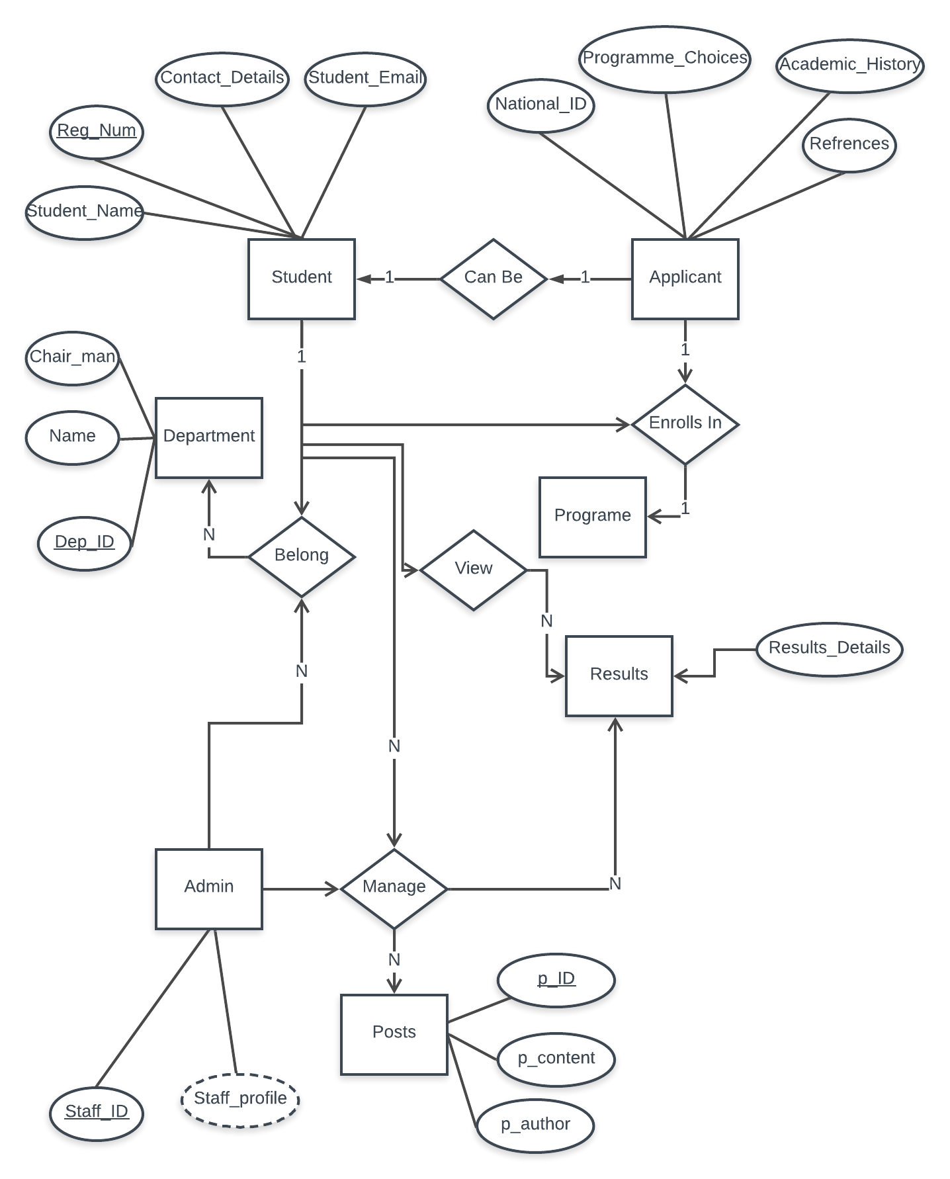

### Use Cases

A use case is a tool for defining the required user interaction. Use case diagrams are considered for high-level requirement analysis of a system. So when the requirements of a system are analyzed the functionalities are captured in use cases. So we can say that uses cases are nothing but the system functionalities written in an organized manner. Use cases consist of Actors. Actors can be defined as something that interacts with the system. The actors can be human user, some internal applications or maybe some external applications. Below is the use case diagram for the proposed system.

|  |
| --- |
| Applicant  Admin  Lecturer  Student |

*Key:*

|  |  |  |  |
| --- | --- | --- | --- |
| System | Use Case | Actor | Relationship |

## DATABASE & FILE DESIGN

The next thing to design is how the data is going to be saved, retrieved and maintained in our system. This section is meant to clearly outline the database and file designs. However, the analyst is not going to design the database for the proposed system since it will be integrated with the database of the current system as it will be shown in the system interface design section.

## INTERFACE DESIGN

According to weopedia, an Interface is a boundary across which two independent systems meet and act on or communicate with each other. Designing these boundaries requires an expert since this is usually where security breaches start and also a system should hide the implementation which does not concern the users or the requesting system and exposes only those that are necessary and understandable to the users.

There are two types of Interfaces that can be found on the proposed system, System Interfaces where the GZU mobile application is going to request resources to the current backend of the system and the User Interface where students are going to request their portal information from the proposed mobile application.

### System Interface design

An interfaces is where the system transforms its inputs to its outputs for other external systems to consume. The collection of all the inputs and outputs of a system define its interfaces. For example, database information, and read and write permissions to the current system database. There will be an Application Programming Interface (API) that will be developed in order to cater for the remote request and control security issues before saving or reading data from the current system’s database, the analyst will talk about the security design in the preceding sections.

### Human-Computer Interface design (HIC)

HCI design is concerned with the design, evaluation, and implementation of interactive computing systems for human use. HCI design emphasizes the usability of the system in the development process. According to *A. Holzinger (2000)* usability is most defined as the ease of and acceptability of a system for a particular class of users carrying out specific tasks in a specific environment.

Based on the above facts and another fact that ease of use affects the user’s performance and their specification, while acceptability affects whether the system is used, at this stage the analyst is going to go into the design of the proposed systems focusing on the forms, dialogs, and reports.

#### Dashboard page Design

|  |
| --- |
| GZU Logo  STUDENT PORTAL  Reg Number  Passord  Forgot Passord?  Login  Not s GZU Student? Apply>> |

#### Instructions to the applicant page design

|  |
| --- |
| Welcome to GZU  (Instructions text)  Required Document 1  Required Document 2  Required Document 3  I’m Ready |

#### Applicant form design

|  |
| --- |
| Personal Details  Last Name  First Names  Date of Birth  Gender **\/**  Marital Status **\/**  National ID  Birth Place  Title **\/**  Citizenship  Nationality  Previous Surname (If any) **\/**  Race **\/**  Province  Religion  + Attach File with copies of your ID & Birth Certificate  Submit |

#### Application home design

|  |
| --- |
| **Welcome M190001**  Tuition Balance RTGS$XXX  Quick Action 1  Quick Action 2  Quick Action 4  Quick Action 3  Quick Action 6  Quick Action 5  Student Wallet RTGS$XX  Top Up > |

#### Exam time table page design

Exam Time Table

|  |
| --- |
| ADD TO MY CALENDAR  Down Town Room 1  **DT1**  **Venue Description**  **Venue Code**  Venue Key  **44**  **12**  **3**  **17**  **09:00**  **14:00**  **09:00**  **09:00**  2019-05-28  2019-05-28  2019-05-28  2019-05-28  **DT1**  **DT4**  **DT1**  **DT1**  HCS3  HCS4  HCS1  HCS2  **Position**  **Time**  **Date**  **Venue**  **Code**  Report Clashes Notice  Time table for June 2019 |

#### Emergency report form design

|  |
| --- |
| Emergency  Submit As  Subject  Urgency  Phone  Address  Enter your emergency  **SEND** |

All the above pages were designed in such a way that it keeps the users informed about what is going on, on every step and providing feedback such as errors if the user input wrong information. And now the analyst will go over to security design of the proposed system.

## SECURITY DESIGN

Security, as part of the software development process, is an ongoing process involving people and practices and ensures application confidentiality, integrity, and availability. The analyst realized that in order to develop secure software, it is very important to implement security at every stage of the development process (Security by design technique). The following are some of the security considered while designing the system:

**Login**: In order to make the application secure, a student must log in before accessing any portal resources and the design here was that the login session expires every week so that the system can verify if it’s still the use but at the same time improving User Experience or not logging in every time.

**Secure API Request (https):** All the data request must be through the https protocol, this will avoid data sniffing and other security issues that came by accessing information over unsecured network protocols

The system will also be able to download data and save to secure SQL mobile storage while it is online so that it can be accessed when the phone went offline.

With these designs, we can rest assured that our system is secure and it ensures confidentiality, integrity, and availability.

## CONCLUSION

Design is one of the crucial stages in the development lifecycle of software and if it is done well it increases the chances of project success. This chapter clearly shows how the analyst designed data flows, interfaces and security of the system and now they can proceed to the implementation phase.